NAME: VENKATRAMAMOORTHY.G
- Declare variables using var, let, and const.
var is function-scoped and can be re-declared, while let is block-scoped and cannot be re-declared. let is safer and preferred in modern JavaScript.
- Var can be re-declare or updated
- Let can be updated but not re-declare in same scope
- Const can’t be re-declare or updated it is once assigned it can’t be changeable.
Example:
var name = "John"; // old way
let age = 20; // modern way
const country = "India"; // constant
- Create variables with string, number, boolean, null, undefined.
CODE:
let Name = "venkat"; //String
let age = 22; //Number
let isstudent = true; //Boolean
let id=null;//Null value
let undefined; //undefined
let no=12343354354354n;//BigInt
let array=[1,2,3];//object
console.log(typeof(Name)+" => "+Name);
console.log(typeof(age)+" => "+age);
console.log(typeof(isstudent)+" => "+isstudent);
console.log(typeof(id)+" => "+id);
console.log(typeof(undefined));
console.log(typeof(array)+" => "+array);
console.log(typeof(no)+" => "+no);
OUTPUT:
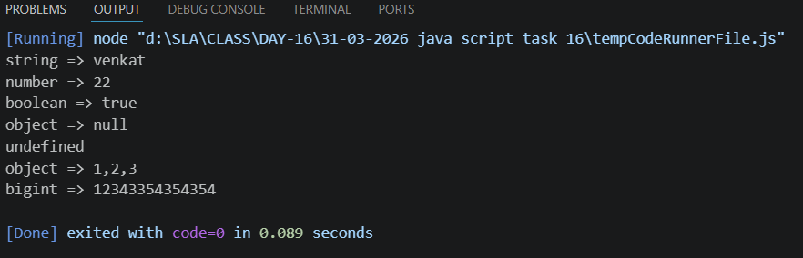
- Use +, -, *, /, %, ==, ===, &&, ||.
Arithmetic:
CODE:
let a = 10;
let b = 5;
console.log("add: "+(a+b));
console.log("sub: "+(a-b));
console.log("mul: "+(a*b));
console.log("div: "+(a/b));
console.log("reminder: "+(a%b));
OUTPUT:
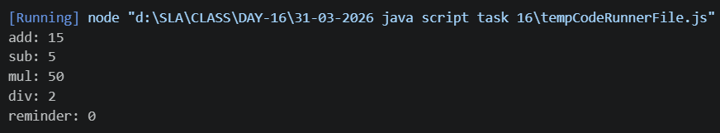
Comparison operator:
CODE:
let x = 5;
let y = "5";
console.log("== : "+(x == y)); // true (checks value only)
console.log("=== : "+(x === y)); // false (checks value + type)
OUTPUT:
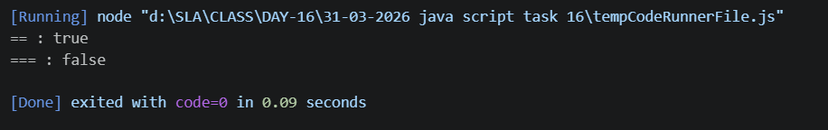
Logical Operator:
CODE:
let num = 18;
let hasID = true;
console.log("AND: "+(num >= 18 && hasID)); // true (AND)
console.log("OR :"+(num < 18 || hasID)); // true (OR)
OUTPUT:
